Energy Efficient Resource Allocation in Wireless
Energy Harvesting Sensor Networks
Prof. Name¹, Student Name²
¹Assistant Professor University/College Place
²Student Qualification University/College Place

Abstract - One of the most crucial difficulties in the widespread adoption of Wireless Sensor Networks is extending the sensor life (WSNs). In recent years, Energy Harvesting (EH) sensors have been suggested as a solution to the aforementioned issue. These sensors can obtain the energy they need from their surroundings in a variety of ways, extending their useful lives. We consider a Wireless Energy Harvesting Sensor Network (WEHSN) based on TDMA in which the time slot consists of two time intervals, the first of which is used to transmit data from the sensors and the second of which is used to absorb energy. With restrictions on time scheduling parameters and transmission power consumption, we examine the efficient resource allocation in WEHSN, where an EH sensor is permitted to send its data if the amount of energy it has harvested exceeds the power it has consumed. We use the Dinkelbach approach to construct the closed form expression for the energy efficiency optimization issue and transform it into a parametric form. Then, we use Karush-Kuhn-Tucker (KKT) conditions to resolve the new issue. The numerical outcomes demonstrate the viability of the suggested approach.

Key Words: Energy Efficiency, Resource Allocation, Energy Harvesting, Wireless Sensor Networks.

1. INTRODUCTION

In recent years, there has been a lot of interest in the rapidly developing fields of Wireless Sensor Networks (WSN) and Internet of Things (IoT) applications such the smart home, smart factory, and others. The efficient use of resources, such as electricity and energy harvesting technology, would increase the lifespan of the sensors and significantly improve system performance.
In, Sultana et al. discussed the use of a cognitive D2D communication system to increase the effectiveness of both spectrum and resource allocation. In order to concurrently deliver an efficient energy and spectrum performance, Nobar et al. studied a cognitive Wireless Powered Communication Networks (WPCN) with green power beacon, in which the secondary network is wirelessly powered by an energy collecting power beacon.
The authors of the paper have investigated two spectrum access schemes for the proposed model, i.e., a random spectrum access and a spectrum-sensing based spectrum access, which results in deriving the closed form expressions for service rate of the Secondary User (SU) and the Primary User (PU). Also, a modified model has been discussed by Nobar et al. in to meet the required criteria of resource-limited cognitive WSNs and to maximize the performance of the secondary network under some QoS constraints. They have applied an infinite battery status for PU but limited battery life time in wireless sensor nodes. Likewise, Ding et al. has studied an iterative joint resource management and time allocation in [7] to maximize the energy efficiency whereas Yang et al. in [8] has tried to maximize the energy efficiency via minimizing the total consumed energy in a cluster-based IoT network with energy harvesting property.
Another approach by Pei et al. in [9], proposes a joint resource block and transmission power control scheme for the energy harvesting D2D communications which applies an under laying Non-Orthogonal Multiple Access (NOMA) scheme to a cellular network under signal-to-interference-andnoise ratio constraint of the Cellular Users (CU). Furthermore, maximizing the network throughput in TDMA and NOMA for uplink wireless powered IoT networks, has studied in [10] by Wu et al, where the spectral and energy efficiency are limited to the circuit energy consumption.
In this letter, we consider an energy efficient resource allocation in a TDMA based WEHSN. Unlike [10], which only has optimized the network throughput, our target is to maximize the energy efficiency by decreasing the total energy consumption in the sensors. We derive the closed form expressions for the optimization problem defined for energy efficiency and then, we apply Dinkelbach algorithm to convert the optimization problem to parametric form and find the optimal resource allocation in the network. Using the mentioned algorithm, leads into much decrease in the energy consumption in the network, consequently, yielding better performance. The rest of this paper is organized as follows: Section II discusses the system model of WEHSN and problem formulation. In Section III resource allocation and optimal solutions are represented. The numerical results are presented in section IV, and finally, Section V concludes the paper.

2. Related Works

[1] J. Huang, C. Xing, and C. Wang, Future communication systems will depend heavily on energy efficiency, which has evolved into a primary design goal for all 5G radio access networks. The need for a new technology that allows wireless devices to harvest energy from the environment by capturing ambient RF signals is driven by the high operational costs and impossibility of replacing or recharging wireless device batteries in many scenarios, such as wireless medical sensors inside the human body. SWIPT has become a potent tool for tackling this problem. In this article, we examine the available SWIPT designs and supporting technologies and list the technical difficulties in implementing SWIPT. To highlight the significance of using SWIPT, we first give an overview of the technologies that enable SWIPT and SWIPT-assisted wireless systems before showcasing a brand-new power distribution method that uses SWIPT. In order to inspire and stimulate additional study on SWIPT, we highlight a few potential future research directions.

[2] K. Kang, R. Ye, In the Internet of Things (IoT) network, where a single hybrid access point (H-AP) with a consistent power source communicates with a variety of IoT devices, wireless power transfer is a new technology that is being studied in this research. It is expected that this H-AP operates in full-duplex mode, which sends and receives signals to and from these Internet of Things devices simultaneously during the entire frame. The H-received AP's signals can be used to generate energy by the IoT devices. Additionally, the uplink transmission is supported by the energy that was captured. One Internet of Things device continues to collect energy until its own uplink time slot because uplink transmission uses time-division multiple access. By utilizing the ideal time allocation strategy for each device, the goal of this research is to maximize the overall surplus energy, which is defined as the difference between the energy available and the energy consumed for uplink transmissions. To address this issue, distributed non-cooperative and bargaining cooperative game-based algorithms are developed. Additionally, the popular KKT condition technique is used as a benchmark. The numerical findings demonstrate that in terms of total surplus energy and the fairness index, the bargaining cooperative algorithm outperforms the distributed non-cooperative algorithm (DNCA) and the KKT algorithm (KKTA). Regarding total surplus energy, DNCA performs better than KKTA, however KKTA is more equitable than DNCA.

[3] Z. Chu, F. Zhou, Z. Zhu, R. Q. Hu, and P. Xiao, In this research, a wireless powered sensor network with many sensor nodes placed to track a specific external environment is investigated. In the wireless energy transfer phase, these sensor nodes are powered by a multiantenna power station (PS), and in the wireless information transfer phase (WIT), the sensor nodes use the energy they have captured to send their own monitoring data to a fusion centre. When two alternative scenarios, such as PS and sensor nodes belonging to the same or different service operators, are taken into consideration, the objective is to optimize the system sum throughput of the sensor network (s). To simultaneously design the energy beamforming and time allocation in the first case, we suggest a global optimal solution. We continue to create a closed-form response for the suggested sum throughput.

[4] A. Sultana, L. Zhao, and X. Fernando, According to LTE and WiMAX advanced standards, device-to-device (D2D) communication is being developed as a new paradigm to improve network performance. Dedicated spectrum (overlay) or shared spectrum may be used for D2D communication (underlay). However, interference between cellular users and D2D users impairs the underlay mode while the assigned specialized spectrum may not be utilized properly in the overlay mode. Can the cognitive approach, in which D2D users opportunistically access the underutilized radio spectrum, be used to optimize the resource allocation of a D2D system? That is the subject of this essay. This work models D2D users as cognitive secondary users and optimizes the transmission rate of the D2D users while concurrently satisfying five sets of power, interference, and data rate limitations.

[5] S. K. Nobar, K. A. Mehr, and J. M. Niya, In this letter, we'll take a look at an RF-powered green cognitive radio network (RF-GCRN), where a power beacon (PB) acts as the hub, harvesting green energy from nearby sources and transmitting it wirelessly to cognitive users. The sole source of energy for cognitive users is random in-band energy transfer by PB. With only one set of secondary users, the performance of this network is examined for both random access and spectrum sensing-based access strategies. If the energy transmission rate is below a specific threshold, the results demonstrate the viability of the RF-GCRN paradigm. The specifications of the spectrum access strategy and the primary user's maximum tolerated delay are used to define this threshold.

3. Implementation

We consider a WEHSN, which consists of one Hybrid
Access Point (HAP) plugged to an infinite power supply and M sensors capable of energy harvesting (see Fig. 1). We use “harvest-and-then-transmit” protocol proposed in [11]. At first, sensors harvest energy in downlink (DL) from a Wireless Energy Transferring (WET), then, they transmit information in uplink (UL) towards a Wireless Information Transmission (WIT). The total time interval for energy harvesting and information transmission is denoted by Tmax. We consider a TDMA-based WEHSN in which whole sensors harvest energy

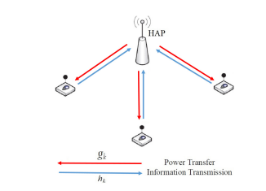

during DL WET and transmit information in duration of UL WIT. The second interval is divided into M slots belonging to each sensor. The perfect Channel State Information (CSI) is assumed to be available in each sensor for resource allocation. The DL channel gain between the HAP and sensor i, and the UL channel gain between sensor i and HAP are denoted by gi and hi, respectively. During the downlink period, HAP broadcasts the energy signal with a constant power P0, during τ0 Omni directionally to all sensor. Thus, the amount of harvested energy at sensor i can be expressed as

here ηi ∈ (0, 1] is the constant energy conversion coefficient of sensor i and Pcri is consumed power in the circuit in energy harvesting period. We assume the amount of harvested energy in each sensor is positive (fi > 0). if fi < 0 the corresponding sensor is prohibited to participate in transmission due to lackof enough energy.

During the uplink period, due to TDMA-based WEHSN,
each sensor transmits information in allocated time slot τi. Therefore, the consumed energy in each sensor during the information transmission will be equal to (pi+Pcti)τi , where pi denotes the power allocated for sensor i in WIT and Pcti is the circuit power consumption in information transmission period. Then, the achievable throughput (normalized by bandwidth) for sensor i can be expressed as

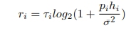

First, we assume that τ0 and {τi} are fixed. In this case, problem (8) is a convex optimization problem related to {pi} and also satisfies the Slater’s condition [13]. Thus, the optimal solution can be obtained efficiently by applying the Lagrange dual method [13]. To this end, we need the Lagrangian function of problem (8) which can be written as
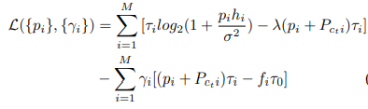
where {γi} is Lagrangian coefficient. Due to complementary slackness, the optimal lagrange multipliers are zero in constraints C3, so the corresponding lagrangian multipliers i constraints C3 are omitted in equation (9). To satisfy KarushKuhn-Tucker (KKT) [13] conditions we have
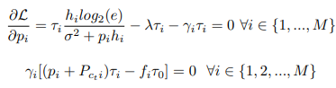

To solve (10) and (11), we consider three cases.
Case 1) γi 6= 0 ∀i ∈ {1, 2, ..., M}, in this case we have
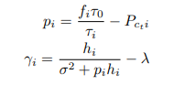
To satisfy KKT, both {pi} and {γi} should be greater than zero (0 < {pi} & 0 < {γi}).
Case 2) where γi = 0 ∀i ∈ {1, 2, ..., M}, in this case we have
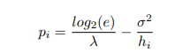
Case 3) In this case, first, we separate zero and nonzero γis so that γi 6= 0 ∀i ∈ {1, 2, ..., K} and γi = 0 ∀i ∈ {K + 1, ..., M}. Then, according to equations (12) and (14), we could obtain the pi corresponding to each γi.
Case 1) To obtain the pair (τ0, {τi}), we substitute (12) in maximization problem (8). Thus, the problem is converted to
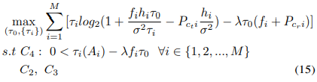
where Ai = (1 − λσ2hi + λPcti) and constraint C4 comes from substituting (12) in (13) to satisfy 0 < {γi} constraint C2, C3, C4 are linear, then the object function in (8) could be rewritten as
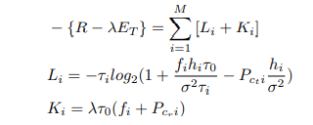

Where, ∇2 (Li) > 0 proves the convexity of Li and Ki appears to be linear function from equation (17).
Thus, the maximization problem (15) is a concave optimization problem and also satisfies the Slater’s condition. To obtain optimal solution, the Lagrangian function of problem (15) takes a form as
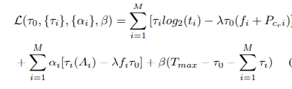
where ti = (1 + fihiτ0 σ2τi – Pcti hi σ2 ) and {αi} and β are Lagrangian coefficients. Since the amount of Pcti is assumed to be negligible, ti will be positive. Then, the KKT condition are as following
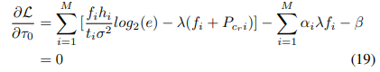
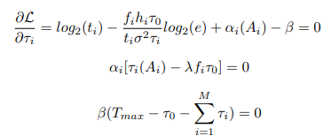
Since γi 6= 0 for i ∈ {1, 2, ..., M} and constraint C4, the parameter αi is equal to zero from (21). Substituting (20) in (19), we obtain the following equation
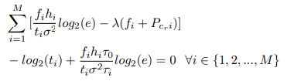
Defining θi = τ0 τi, all θis ∀i ∈ {1, 2, ..., M} can be found from(23). Also, to satisfy (22), we should have (τ0 +PM i=1 τi =Tmax), therefore, we can derive τ0 and τi ∀i ∈ {1, 2, ..., M} as follow
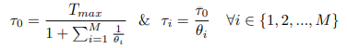
Case 2) To obtain related (τ0, {τi}) in case two, we substitute (14) in problem (8). Thus, the problem described in (8) is converted to
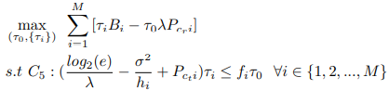
where Bi = (log2(log2(e)hiσ2λ) − log2(e) + σ2λhi− λPcti). The maximization problem in (25) is a linear optimization problem. Therefore, (τ0, {τi}) can be easily calculated.
Case 3) By inserting the calculated pi from case three in problem (8), it is converted to (26), which is combination of problems (15) and (25)
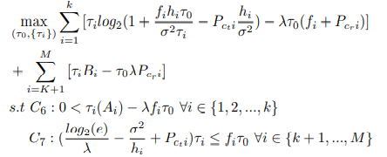
The solution for problem (26) to acquire τ0 and τi, could be obtained similar to case (1) using the equation (24).

4. Results

After 5000 rounds the number of nodes alive are plotted in the below graph. It can be noted that total number of nodes started to die after some 3500 or more rounds which is the maximum capacity we have achieved with this type of protocol.

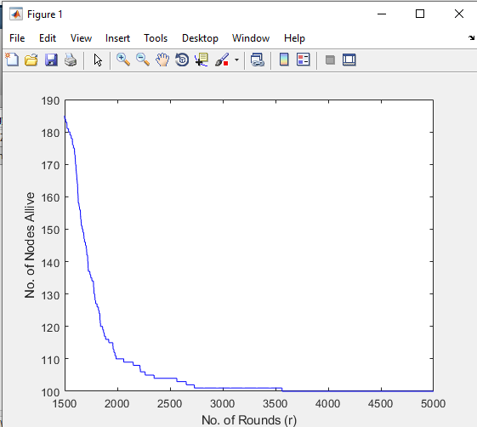
Fig -1: No of Nodes Alive after 5000 Rounds

After 5000 rounds, the consumption of energy of all the nodes in the network are plotted in the below graph. It can be noted that, the energy consumption is stretched to more than 2500 rounds which is possible because of our proposed protocol.

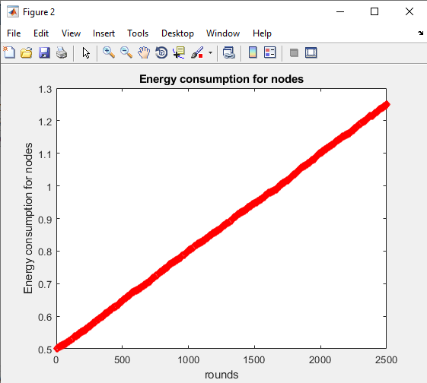
Fig -2: Energy Consumption for Nodes

Energy efficiency vs HAP transmit power are plotted in the below graph, which shows a greater usage of transmit power for making the nodes alive to some longer rounds than typical limit. It shows that, the current protocol can maximize the power usage minimal power.

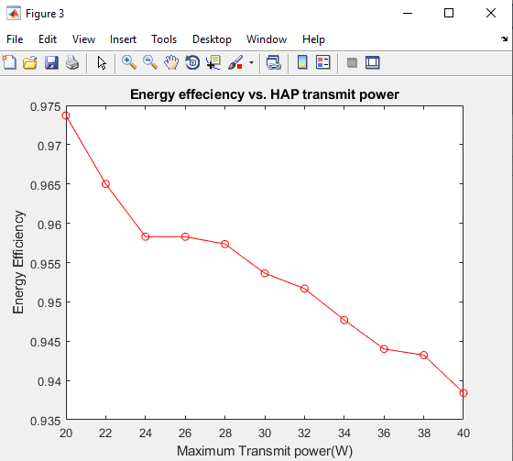

Fig -3: Energy Efficiency Vs HAP Transmit Power

Throughput vs HAP transmit power are plotted in the below graph which shows the increase of transmit power when the throughput minimizes shows that the proposed protocol maximized the throughput of the network.

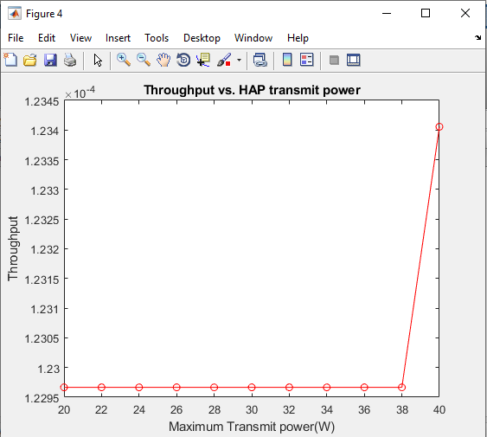

Fig -4: Throughput Vs HAP Transmit Power

5. CONCLUSION

In this article, we provide a brand-new system design where wireless sensors gather the energy needed for data transmission, then transmit using the harvest-then-transmit protocol. Additionally, the sensors interact with a hybrid access point during the remaining time span using TDMA. We get at the energy efficiency optimization problem by putting limits to the time scheduling parameter and transmission power for each sensor to the system performance. Using the Dinkelbach algorithm, the issue is resolved, and closed form expressions are obtained. The numerical findings demonstrate that while the throughput could slightly fall in comparison to the other ways, the energy usage would decrease significantly more, leading to higher energy efficiency as the network performance.

REFERENCES

[1] J. Huang, C. Xing, and C. Wang, “Simultaneous wireless information and power transfer: Technologies, applications, and research challenges,” IEEE Communications Magazine, vol. 55, no. 11, pp. 26–32, Nov 2017.

[2] K. Kang, R. Ye, Z. Pan, J. Liu, and S. Shimamoto, “Full-duplex wireless powered iot networks,” IEEE Access, vol. 6, pp. 53 546–53 556, 2018.

[3] Z. Chu, F. Zhou, Z. Zhu, R. Q. Hu, and P. Xiao, “Wireless powered sensor networks for internet of things: Maximum throughput and optimal power allocation,” IEEE Internet of Things Journal, vol. 5, no. 1, pp. 310–321, Feb 2018.

[4] A. Sultana, L. Zhao, and X. Fernando, “Efficient resource allocation in device-to-device communication using cognitive radio technology,” IEEE Transactions on Vehicular Technology, vol. 66, no. 11, pp. 10 024– 10 034, Nov 2017.

[5] S. K. Nobar, K. A. Mehr, and J. M. Niya, “Rf-powered green cognitive radio networks: Architecture and performance analysis,” IEEE Communications Letters, vol. 20, no. 2, pp. 296–299, Feb 2016.

[6] S. K. Nobar, K. A. Mehr, J. M. Niya, and B. M. Tazehkand, “Cognitive radio sensor network with green power beacon,” IEEE Sensors Journal, vol. PP, no. 99, pp. 1–1, 2017.

